Making Ice Cream Sandwiches
How do I make Soft Serve and Hand Dipped Ice Cream Sandwiches?

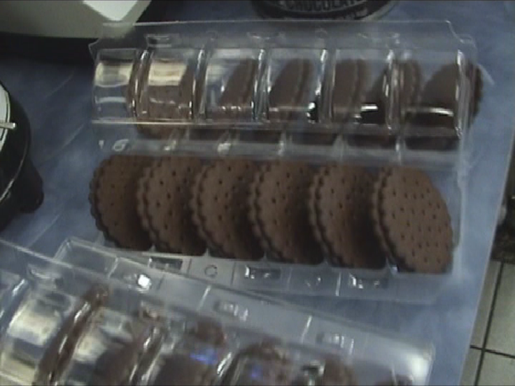
Step 1
You will need 12 Cookie Wafers and a 6-slot, Plastic Sandwich container or Take-Out carry case.

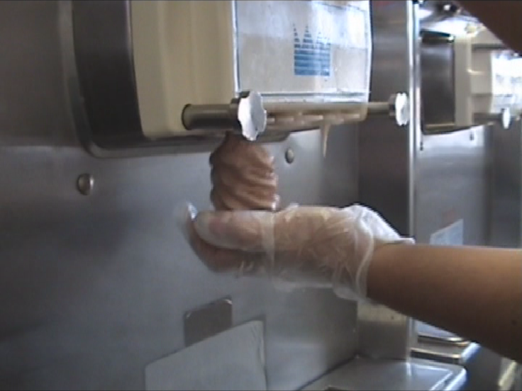
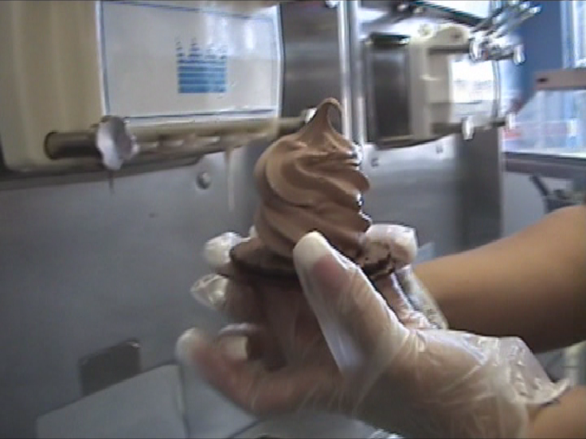

Step 2
Select a flavor of Soft Serve and put a 3-swirl serving on a Cookie Wafer or…

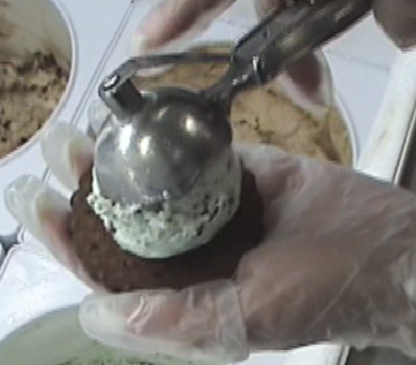
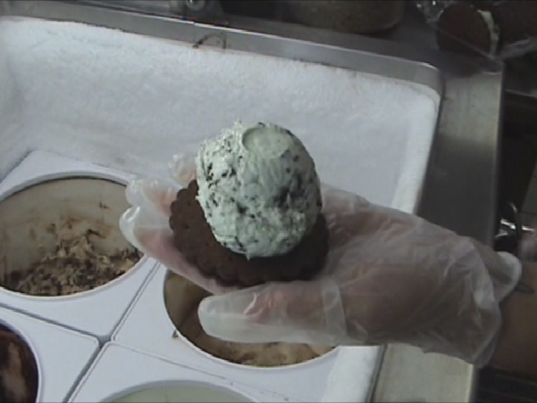

Step 3
Select a flavor of Hand-Dipped Ice Cream and put one 4oz scoop on a Cookie Wafer.

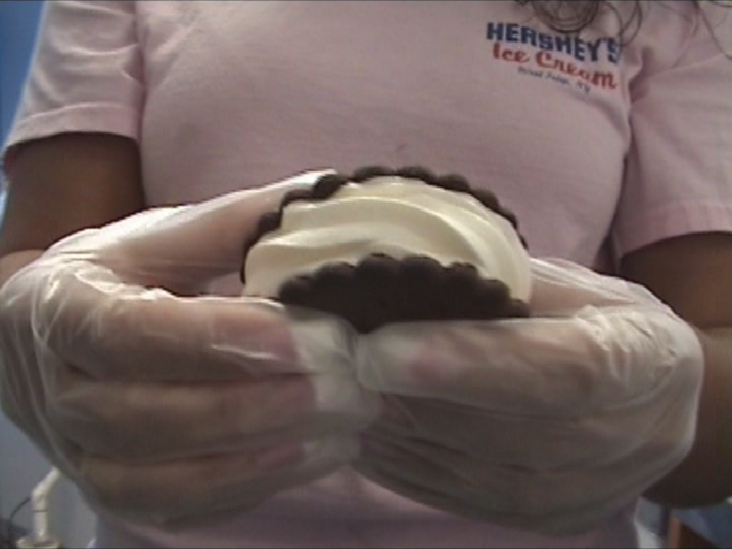
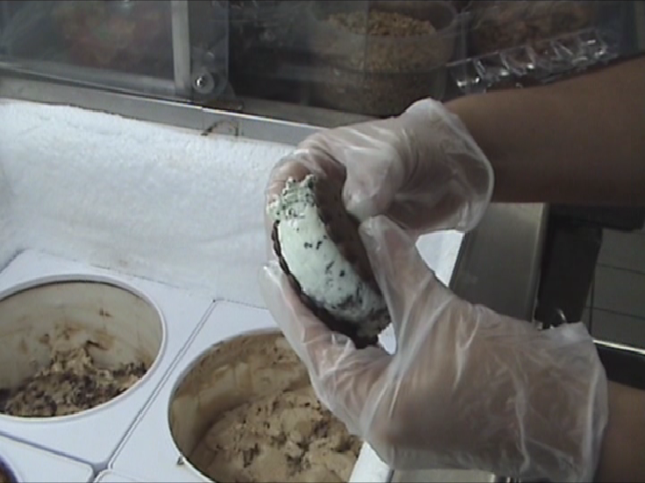

Step 4
Place a Second wafer on top and gently squeeze the wafers until the sandwich fits into the grooves of your sandwich holder.

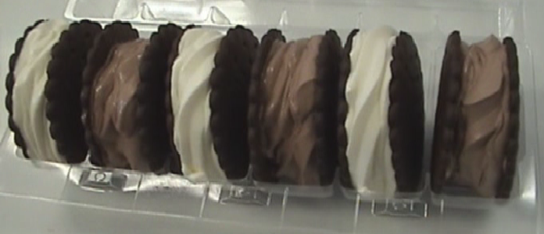
Place your sandwiches in a display case for a for Grab-n-go item, or try variety packs of your most popular flavors

